ZL Application AWS EKS Deployment Guide
Version: 1.1 Last Updated: December 13, 2025

Executive Summary

About This Document
This document provides a comprehensive guide for deploying the ZL Application on Amazon Elastic Kubernetes Service (EKS). It captures all steps taken during the initial deployment, including AWS resource provisioning, Kubernetes configuration, storage setup, and application deployment.

Purpose
- Serve as a reference for the deployed ZL application infrastructure
- Enable reproducibility for future deployments or disaster recovery
- Document architectural decisions and configurations
- Provide troubleshooting guidance for common issues

Deployment Overview
The ZL Application is deployed as a containerized microservices architecture:
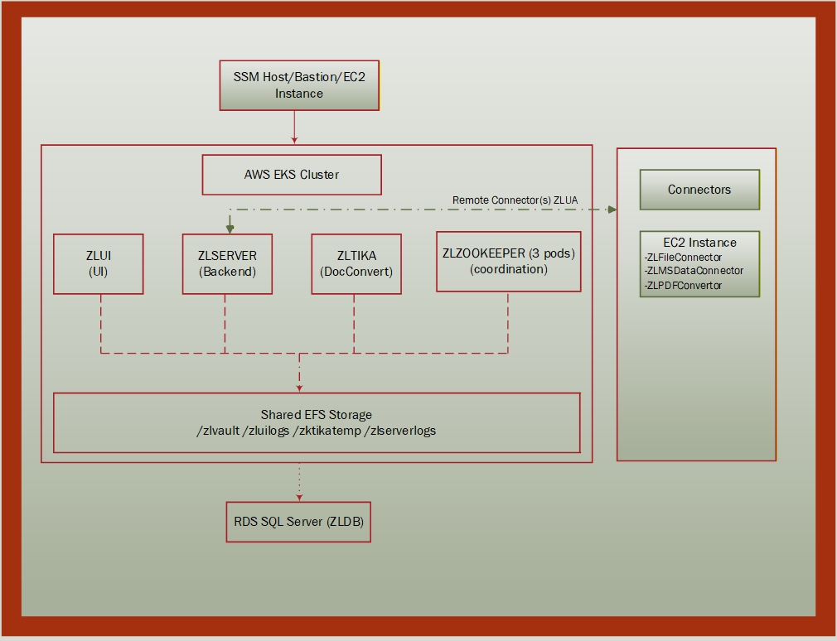Figure 1: ZL Microservices Architecture

Key Components
Component | Technology | Purpose
Container Runtime | AWS EKS 1.34 | Kubernetes orchestration
Worker Nodes | m5.xlarge (2-5 nodes) | Application compute
Container Registry | AWS ECR | Docker image storage
Shared Storage | AWS EFS | Logs, temp files, vault data
Block Storage | AWS EBS (gp3) | ZooKeeper persistent data
Database | AWS RDS SQL Server | Application database
Load Balancer | AWS ALB | Public internet access
DNS | Kubernetes internal DNS | Service discovery

Access Information
Resource | Endpoint/URL
Application URL | http://k8s-default-zluiingr-e9951b35c2-755748288.us-west-1.elb.amazonaws.com
EKS Cluster | usw1-zlps-eks-01 (us-west-1)
Database | usw1-zlps-msexpsql-01-eks.c5s06occm2dn.us-west-1.rds.amazonaws.com:1433
ECR Repository | 995553364920.dkr.ecr.us-west-1.amazonaws.com/uw1-zlps-ecr-01

Shell/Terminal Compatibility Reference
Shell | OS | Line Continuation | Variable Substitution
PowerShell | Windows | ` (backtick) | $VAR or $env:VAR
CMD | Windows | ^ (caret) | %VAR%
Bash | Linux/macOS | \ (backslash) | $VAR or ${VAR}
Important Notes:
- "All Shells" means the command works identically in PowerShell, CMD, and Bash
- kubectl and eksctl commands generally work the same across all shells
- AWS CLI commands may need different quoting/escaping per shell
- Commands that run inside containers (kubectl exec) use bash regardless of host shell

Table of Contents
- 1. Environment Overview
- 2. Phase 1: EKS Cluster Creation
- 3. Phase 2: ECR Setup and Image Management
- 4. Phase 3: EBS CSI Driver Installation
- 5. Phase 4: EFS CSI Driver and Storage
- 6. Phase 5: S3 CSI Driver (Optional)
- 7. Phase 6: Database Configuration
- 8. Phase 7: ZooKeeper Deployment
- 9. Phase 8: Application Deployment
- 10. Phase 9: Network and Ingress Configuration
- 11. Phase 10: Cluster Autoscaling
- 12. Phase 11: Post-Deployment Configuration
- 13. Troubleshooting
Appendices:
- Appendix A: YAML File Reference
- Appendix B: EFS Access Points and Vault Mount Structure
- Appendix C: ConfigMaps and Secrets
- Appendix D: Services and Networking
- Appendix E: Secure Deployment (No Internet Access)

Environment Overview

AWS Resources Created
Resource Type | Name/ID | Purpose
EKS Cluster | usw1-zlps-eks-01 | Kubernetes control plane
Node Group | uw1-zlps-ng-01 | Worker nodes (m5.xlarge)
VPC | vpc-07644cdd0224da4f3 | Network isolation
ECR Repository | uw1-zlps-ecr-01 | Container image storage
EFS File System | fs-0a4ec87cd91178047 (usw1-zlps-efs-01) | Shared persistent storage
RDS Instance | usw1-zlps-msexpsql-01-eks | SQL Server database
S3 Bucket | usw1-zlps-app-storage | Archive storage
ALB | k8s-default-zluiingr-e9951b35c2 | Public load balancer

Network Configuration
Subnet ID | Type | Availability Zone | CIDR
subnet-01c24772a882a3a1b | Public | us-west-1a | 192.168.0.0/19
subnet-06eb80d784d985109 | Public | us-west-1c | 192.168.32.0/19
subnet-0c861c54ffa4ddbe6 | Private | us-west-1a | 192.168.64.0/19
subnet-039bd7f435475c3dc | Private | us-west-1c | 192.168.96.0/19

Security Groups
Group ID | Name | Purpose
sg-0afb0a3f0c30ba84d | eksctl-usw1-zlps-eks-01-cluster-ClusterSharedNodeSG | Node communication
sg-07a77dc047e9fb6fe | eks-cluster-sg-usw1-zlps-eks-01-6457660 | Cluster SG

Docker Images
Image Tag | Purpose
zlserver-11.0.1-b123 | ZL Server application
zltika-11.0.1-b123 | Document conversion service
zlzookeeper-11.0.1-b123 | ZooKeeper coordination service

PHASE 1: EKS Cluster Creation

STEP 1: Create EKS Cluster

📋 Explanation
Creates a managed Amazon EKS (Elastic Kubernetes Service) cluster with an associated node group for running containerized workloads.

⚙️ What It Does
- Provisions a fully managed Kubernetes control plane in AWS
- Creates a managed node group with EC2 instances as worker nodes
- Sets up networking, IAM roles, and security groups automatically
- Configures kubectl context for cluster access

❓ Why It's Needed
EKS provides the foundation for running the ZL Application. Without a Kubernetes cluster, there is no platform to deploy containers, manage scaling, or orchestrate the application services.

📌 Prerequisite Tasks
- AWS CLI configured with appropriate credentials
- eksctl installed on local machine
- IAM user/role with permissions to create EKS clusters
- Sufficient AWS service quotas for EC2 instances

🔗 Dependent Tasks
- Step 2: Associate OIDC Provider (requires cluster to exist)
- Step 3: Get Cluster OIDC Issuer
- Step 4: Get Cluster VPC Information
- All subsequent phases depend on cluster availability

💻 Code Block
PowerShell Bash Windows CMD

Parameter Details
Parameter | Value | Description
--name | usw1-zlps-eks-01 | Unique cluster name following naming convention
--version | 1.34 | Kubernetes version
--region | us-west-1 | AWS region for deployment
--nodegroup-name | uw1-zlps-ng-01 | Worker node group identifier
--node-type | m5.xlarge | EC2 instance type (4 vCPU, 16GB RAM)
--nodes | 2 | Initial number of worker nodes
--nodes-min | 1 | Minimum nodes for autoscaling
--nodes-max | 2 | Maximum nodes for autoscaling
--managed | - | Use AWS-managed node group

STEP 2: Associate OIDC Provider

📋 Explanation
Associates an IAM OpenID Connect (OIDC) identity provider with the EKS cluster to enable IAM roles for Kubernetes service accounts.

⚙️ What It Does
- Creates an IAM OIDC identity provider linked to the cluster
- Enables Kubernetes service accounts to assume IAM roles
- Establishes trust relationship between Kubernetes and AWS IAM

❓ Why It's Needed
Without OIDC association, Kubernetes pods cannot use IAM roles for AWS service access. This is required for:
- EBS CSI Driver to create/attach EBS volumes
- EFS CSI Driver to mount EFS file systems
- S3 CSI Driver to access S3 buckets
- Any pod needing AWS API access

💻 Code Block
All Shells (PowerShell, Bash, CMD):
eksctl utils associate-iam-oidc-provider --region us-west-1 --cluster usw1-zlps-eks-01 --approve

STEP 3: Get Cluster OIDC Issuer

📋 Explanation
Retrieves the OIDC issuer URL from the EKS cluster, which is needed for creating IAM trust policies.

⚙️ What It Does
- Queries the EKS cluster for its OIDC issuer endpoint
- Returns the URL used in IAM role trust policies
- Provides the identity provider identifier

💻 Code Block
All Shells:
aws eks describe-cluster --name usw1-zlps-eks-01 --region us-west-1 --query "cluster.identity.oidc.issuer" --output text
Expected Output:
https://oidc.eks.us-west-1.amazonaws.com/id/C0CA93DEA5736D0F19AC427D5A0A123E

STEP 4: Get Cluster VPC Information

📋 Explanation
Retrieves the VPC ID and subnet IDs associated with the EKS cluster for configuring additional AWS resources.

⚙️ What It Does
- Queries cluster configuration for networking details
- Returns VPC ID where cluster is deployed
- Lists all subnet IDs (public and private)

❓ Why It's Needed
Additional AWS resources (EFS, RDS, security groups) must be deployed in the same VPC as the EKS cluster.

💻 Code Block
All Shells:
aws eks describe-cluster --name usw1-zlps-eks-01 --query "cluster.resourcesVpcConfig.{VPC: vpcId, Subnets: subnetIds}" --output table
Expected Output:
--------------------------------------------------
| DescribeCluster |
+-------+----------------------------------------+
| VPC | vpc-07644cdd0224da4f3 |
+-------+----------------------------------------+
|| Subnets ||
|+----------------------------------------------+|
|| subnet-01c24772a882a3a1b ||
|| subnet-06eb80d784d985109 ||
|| subnet-0c861c54ffa4ddbe6 ||
|| subnet-039bd7f435475c3dc ||
|+----------------------------------------------+|

PHASE 2: ECR Setup and Image Management

Overview
Amazon Elastic Container Registry (ECR) is AWS's private Docker image registry. This phase sets up the container registry where your application images are stored and creates the necessary credentials for EKS to pull these images.

Why ECR Is Needed
- Provides secure, private storage for your proprietary container images
- Integrates natively with AWS IAM for access control
- Eliminates need to manage your own Docker registry infrastructure
- Images are stored close to your EKS cluster for fast pulls
- Supports image scanning for security vulnerabilities

Images Stored In This Repository
Image Tag | Size | Purpose
zlserver-11.0.1-b123 | ~800MB | ZL Server/UI application
zltika-11.0.1-b123 | ~600MB | Document conversion (Apache Tika)
zlzookeeper-11.0.1-b123 | ~400MB | ZooKeeper coordination service

STEP 5: Create ECR Repository

📋 Explanation
Creates a private Amazon Elastic Container Registry repository to store Docker images for the ZL Application.

⚙️ What It Does
- Provisions a private Docker registry in your AWS account
- Enables automatic vulnerability scanning on image push
- Generates a unique repository URI for image references

❓ Why It's Needed
EKS pods need to pull container images from a registry. Public registries like Docker Hub have rate limits and expose images publicly. ECR provides:
- Unlimited pulls within AWS (no rate limiting)
- Private storage (only your AWS account can access)
- IAM-based security (integrates with AWS permissions)
- Regional storage (fast pulls from same region as EKS)

💻 Code Block
All Shells:
aws ecr create-repository --repository-name uw1-zlps-ecr-01 --region us-west-1 --image-scanning-configuration scanOnPush=true
Expected Output:
{
"repository": {
"repositoryArn": "arn:aws:ecr:us-west-1:995553364920:repository/uw1-zlps-ecr-01",
"repositoryUri": "995553364920.dkr.ecr.us-west-1.amazonaws.com/uw1-zlps-ecr-01",
"registryId": "995553364920",
"repositoryName": "uw1-zlps-ecr-01"
}
}

STEP 6: Verify ECR Repository

📋 Explanation
Confirms the ECR repository exists and is accessible before proceeding with image operations.

💻 Code Block
All Shells:
aws ecr describe-repositories --repository-names uw1-zlps-ecr-01 --region us-west-1

STEP 7: Authenticate Docker to ECR

📋 Explanation
Logs Docker into ECR so you can push container images to the private repository.

⚙️ What It Does
- Generates a temporary authentication token (valid 12 hours)
- Authenticates the local Docker client with ECR
- Enables docker push commands to the ECR registry

💻 Code Block
PowerShell Bash Windows CMD

Expected Output:
Login Succeeded

STEP 8: Push Images to ECR

📋 Explanation
Uploads the ZL Application container images from your local machine to ECR.

⚙️ What It Does
- Tags local Docker images with the ECR repository URI
- Uploads image layers to ECR storage
- Makes images available for EKS pods to pull

💻 Code Block
All Shells:
# Tag local images for ECR
docker tag zlserver:11.0.1-b123 995553364920.dkr.ecr.us-west-1.amazonaws.com/uw1-zlps-ecr-01:zlserver-11.0.1-b123
docker tag zltika:11.0.1-b123 995553364920.dkr.ecr.us-west-1.amazonaws.com/uw1-zlps-ecr-01:zltika-11.0.1-b123
docker tag zlzookeeper:11.0.1-b123 995553364920.dkr.ecr.us-west-1.amazonaws.com/uw1-zlps-ecr-01:zlzookeeper-11.0.1-b123

# Push images to ECR
docker push 995553364920.dkr.ecr.us-west-1.amazonaws.com/uw1-zlps-ecr-01:zlserver-11.0.1-b123
docker push 995553364920.dkr.ecr.us-west-1.amazonaws.com/uw1-zlps-ecr-01:zltika-11.0.1-b123
docker push 995553364920.dkr.ecr.us-west-1.amazonaws.com/uw1-zlps-ecr-01:zlzookeeper-11.0.1-b123

STEP 9: List Images in ECR

📋 Explanation
Verifies all container images were uploaded successfully to ECR.

💻 Code Block
All Shells:
aws ecr describe-images --repository-name uw1-zlps-ecr-01 --region us-west-1

STEP 10: Create ECR Pull Secret in kube-system

📋 Explanation
Creates a Kubernetes Secret containing ECR credentials in the kube-system namespace, allowing system components to pull images.

⚙️ What It Does
- Creates a docker-registry type Secret in kube-system namespace
- Stores ECR authentication credentials
- Enables CSI drivers and system pods to pull images from private ECR

💻 Code Block
PowerShell Bash Windows CMD

STEP 11: Create ECR Pull Secret in default namespace

📋 Explanation
Creates a Kubernetes Secret containing ECR credentials in the default namespace, allowing application pods to pull images.

❓ Why It's Needed
The default namespace is where all ZL application pods run. Secrets are namespace-scoped, so you need one in each namespace that pulls images. Without this secret, pods will fail with "ImagePullBackOff".

Dependent Deployments
Step | Deployment | Image Referenced
32 | zlzookeeper | uw1-zlps-ecr-01:zlzookeeper-11.0.1-b123
35 | zltika | uw1-zlps-ecr-01:zltika-11.0.1-b123
36 | zlserver | uw1-zlps-ecr-01:zlserver-11.0.1-b123
37 | zlui | uw1-zlps-ecr-01:zlserver-11.0.1-b123

💻 Code Block
PowerShell Bash Windows CMD

PHASE 3: EBS CSI Driver Installation

Overview
The Amazon EBS CSI (Container Storage Interface) Driver enables Kubernetes to manage EBS volumes for persistent storage. This is essential for stateful applications like ZooKeeper that require data persistence across pod restarts.

Why EBS CSI Driver Is Needed
- Provides block storage for stateful workloads
- Enables dynamic volume provisioning via StorageClass
- Supports volume snapshots for backup/recovery
- Required for ZooKeeper's persistent data storage
- Managed lifecycle through Kubernetes PVC/PV

STEP 12: Create EBS CSI Driver IAM Policy

📋 Explanation
Creates an IAM policy that grants the EBS CSI Driver permissions to manage EBS volumes on behalf of Kubernetes.

⚙️ What It Does
- Creates a custom IAM policy from a JSON file
- Grants permissions to create, attach, detach, and delete EBS volumes
- Allows volume snapshot operations
- Returns a policy ARN for attachment to service accounts

💻 Code Block
All Shells:
aws iam create-policy --policy-name AmazonEBSCSIDriverPolicy --policy-document file://policies/Amazon_EBS_CSI_Driver_Policy.json
Expected Output:
Policy ARN: arn:aws:iam::995553364920:policy/AmazonEBSCSIDriverPolicy
View JSON

STEP 13: Create IAM Service Account for EBS CSI Driver

📋 Explanation
Creates a Kubernetes service account linked to an IAM role, allowing the EBS CSI Driver to assume AWS permissions.

⚙️ What It Does
- Creates a Kubernetes ServiceAccount in kube-system namespace
- Creates an IAM role with trust policy for the EKS OIDC provider
- Attaches the EBS CSI policy to the role
- Links the ServiceAccount to the IAM role via annotations

💻 Code Block
All Shells:
eksctl create iamserviceaccount --name ebs-csi-controller-sa --namespace kube-system --cluster usw1-zlps-eks-01 --attach-policy-arn arn:aws:iam::995553364920:policy/AmazonEBSCSIDriverPolicy --approve --role-name AmazonEKS_EBS_CSI_DriverRole

STEP 14: Install EBS CSI Driver (kubectl method)

📋 Explanation
Installs the EBS CSI Driver using kubectl with kustomize overlays from the official GitHub repository.

💻 Code Block
All Shells:
kubectl apply -k "github.com/kubernetes-sigs/aws-ebs-csi-driver/deploy/kubernetes/overlays/stable/ecr/?ref=release-1.53"
Note: Step 15 (EKS Add-on method) is recommended over this method for production deployments.

STEP 15: Install EBS CSI Driver as EKS Add-on Recommended

📋 Explanation
Installs the EBS CSI Driver as a managed EKS add-on, which AWS maintains and updates automatically.

❓ Why It's Needed
Using the managed add-on provides:
- Automatic security patches
- Version compatibility with EKS cluster
- AWS support coverage
- Simplified upgrade path

💻 Code Block
All Shells:
aws eks create-addon --cluster-name usw1-zlps-eks-01 --addon-name aws-ebs-csi-driver --service-account-role-arn arn:aws:iam::995553364920:role/AmazonEKS_EBS_CSI_DriverRole --region us-west-1

STEP 16: Verify EBS CSI Driver Installation

📋 Explanation
Confirms the EBS CSI Driver pods are running and healthy in the cluster.

💻 Code Block
All Shells:
kubectl get pods -n kube-system -l app=ebs-csi-controller
Expected Output:
NAME READY STATUS RESTARTS AGE
ebs-csi-controller-54b57d7767-xxxxx 6/6 Running 0 5m
ebs-csi-controller-54b57d7767-yyyyy 6/6 Running 0 5m

STEP 17: Create EBS StorageClass

📋 Explanation
Deploys a Kubernetes StorageClass that defines how EBS volumes are dynamically provisioned.

❓ Why It's Needed
StorageClass is required for dynamic volume provisioning. ZooKeeper's StatefulSet uses volumeClaimTemplates that reference this StorageClass to automatically create EBS volumes.

💻 Code Block
All Shells:
kubectl apply -f yaml/ebs-sc.yaml
Verify StorageClass:
kubectl get storageclass ebs-sc
View YAML

PHASE 4: EFS CSI Driver and Storage

Overview
The Amazon EFS CSI Driver enables Kubernetes pods to use Amazon Elastic File System for shared, persistent storage. Unlike EBS (block storage), EFS provides network-attached storage that can be accessed by multiple pods simultaneously.

Why EFS Is Needed
- Shared Storage: Multiple pods can read/write the same files
- Persistence: Data survives pod restarts and rescheduling
- Scalability: Automatically scales with usage

Use Cases in ZL Application
Mount Path | Purpose
/zlvault | Main application vault (shared across all pods)
/zluilogs | UI log files
/zlserverlogs | Server log files
/zltikatemp | Tika temporary file processing

EFS Access Points Created
Access Point Name | Access Point ID | Mount Path | Purpose
zlvault-ap | fsap-070de74811e8c461f | /zlvault | Main application vault
zluilogs-ap | fsap-06e5e523915353e85 | /zluilogs | UI logs
zlserverlogs-ap | fsap-0e3cf05f6ae8f8a82 | /zlserverlogs | Server logs
zltikatemp-ap | fsap-08c3382b23a64f7fd | /zltikatemp | Tika temp files

STEP 18: Create EFS IAM Policy

📋 Explanation
Creates an IAM policy that grants permissions for the EFS CSI Driver to interact with Amazon EFS.

💻 Code Block
All Shells:
aws iam create-policy --policy-name ZLEFSPolicy --policy-document file://policies/EFS-IAM-policy.json
Expected Output:
Policy ARN: arn:aws:iam::995553364920:policy/ZLEFSPolicy
View JSON

STEP 19: Create IAM Service Account for EFS CSI Driver

📋 Explanation
Creates a Kubernetes service account with IAM role permissions for the EFS CSI Driver.

💻 Code Block
All Shells:
eksctl create iamserviceaccount --cluster usw1-zlps-eks-01 --namespace kube-system --name efs-csi-controller-sa --attach-policy-arn arn:aws:iam::aws:policy/service-role/AmazonEFSCSIDriverPolicy --approve --role-name AmazonEKS_EFS_CSI_DriverRole
Note: This uses the AWS-managed policy AmazonEFSCSIDriverPolicy rather than the custom policy from Step 18.

STEP 20: Install EFS CSI Driver as EKS Add-on

📋 Explanation
Installs the EFS CSI Driver as a managed EKS add-on for AWS-managed updates and support.

💻 Code Block
All Shells:
aws eks create-addon --cluster-name usw1-zlps-eks-01 --addon-name aws-efs-csi-driver --service-account-role-arn arn:aws:iam::995553364920:role/AmazonEKS_EFS_CSI_DriverRole --region us-west-1
Verify Installation:
kubectl get pods -n kube-system -l app=efs-csi-controller

STEP 21: Create EFS File System

📋 Explanation
Creates an Amazon EFS file system that will provide shared storage for the ZL Application pods.

💻 Code Block
All Shells:
aws efs create-file-system --region us-west-1 --performance-mode generalPurpose --throughput-mode bursting --tags Key=Name,Value=usw1-zlps-efs-01
Expected Output:
File System ID: fs-0a4ec87cd91178047
Important: Save the File System ID - it's required for all subsequent EFS operations.

STEP 22: Create Mount Targets (One Per Availability Zone)

📋 Explanation
Creates EFS mount targets in each availability zone where EKS nodes run, enabling network connectivity to EFS.

❓ Why It's Needed
Mount targets provide the network interface for EFS. Without mount targets in each AZ, pods in that zone cannot access EFS storage.

💻 Code Block
For us-west-1a:
aws efs create-mount-target --file-system-id fs-0a4ec87cd91178047 --subnet-id subnet-01c24772a882a3a1b --security-groups sg-0afb0a3f0c30ba84d --region us-west-1
For us-west-1c:
aws efs create-mount-target --file-system-id fs-0a4ec87cd91178047 --subnet-id subnet-06eb80d784d985109 --security-groups sg-0afb0a3f0c30ba84d --region us-west-1
Verify Mount Targets:
aws efs describe-mount-targets --file-system-id fs-0a4ec87cd91178047 --region us-west-1

STEP 23: Create EFS Access Points

📋 Explanation
Creates access points that provide application-specific entry points into the EFS file system with enforced user identity and root directory isolation.

❓ Why It's Needed
Access points provide:
- Isolation: Each application directory is isolated
- Security: Enforced user identity prevents privilege escalation
- Simplicity: Pods mount their specific directory without seeing the entire filesystem
- Permissions: Automatic directory creation with correct ownership

💻 Code Block
Create zltikatemp Access Point (Tika temporary files):
PowerShell Bash

Output: fsap-08c3382b23a64f7fd
Create zluilogs Access Point:
aws efs create-access-point --file-system-id fs-0a4ec87cd91178047 --posix-user Uid=1000,Gid=1000 --root-directory "Path=/zluilogs,CreationInfo={OwnerUid=1000,OwnerGid=1000,Permissions=755}" --tags Key=Name,Value=zluilogs-ap --region us-west-1
Output: fsap-06e5e523915353e85
Create zlvault Access Point:
aws efs create-access-point --file-system-id fs-0a4ec87cd91178047 --posix-user Uid=1000,Gid=1000 --root-directory "Path=/zlvault,CreationInfo={OwnerUid=1000,OwnerGid=1000,Permissions=755}" --tags Key=Name,Value=zlvault-ap --region us-west-1
Output: fsap-070de74811e8c461f
Create zlserverlogs Access Point:
aws efs create-access-point --file-system-id fs-0a4ec87cd91178047 --posix-user Uid=1000,Gid=1000 --root-directory "Path=/zlserverlogs,CreationInfo={OwnerUid=1000,OwnerGid=1000,Permissions=755}" --tags Key=Name,Value=zlserverlogs-ap --region us-west-1
Output: fsap-0e3cf05f6ae8f8a82

STEP 24: Deploy EFS StorageClass and PVs

📋 Explanation
Creates the Kubernetes storage resources (StorageClass, PersistentVolumes, PersistentVolumeClaims) that map EFS access points to pod mounts.

💻 Code Block
All Shells:
# StorageClass
kubectl apply -f yaml/efs-sc.yaml

# PersistentVolumes
kubectl apply -f yaml/efs-pv-zltikatemp.yaml
kubectl apply -f yaml/efs-pv-zluilogs.yaml
kubectl apply -f yaml/efs-pv-zlvault.yaml

# PersistentVolumeClaims
kubectl apply -f yaml/efs-pvc-zltikatemp.yaml
kubectl apply -f yaml/efs-pvc-zluilogs.yaml
kubectl apply -f yaml/efs-pvc-zlvault.yaml
Verify PV/PVC Status:
kubectl get pv
kubectl get pvc
Expected Output:
NAME CAPACITY ACCESS MODES RECLAIM POLICY STATUS CLAIM
efs-pv-zltikatemp 10Gi RWX Retain Bound default/efs-pvc-zltikatemp
efs-pv-zluilogs 10Gi RWX Retain Bound default/efs-pvc-zluilogs
efs-pv-zlvault 100Gi RWX Retain Bound default/efs-pvc-zlvault

PHASE 5: S3 CSI Driver Optional

Overview
The S3 CSI Driver (Mountpoint for Amazon S3) enables Kubernetes pods to mount S3 buckets as file systems. This is optional and used for archive storage where cost-effective, scalable object storage is preferred.

Why S3 Storage May Be Needed
- Cost Effective: S3 is significantly cheaper than EBS/EFS for large datasets
- Scalability: Unlimited storage capacity
- Durability: 99.999999999% (11 9's) durability
- Archive Use Cases: Long-term retention, compliance archives, cold data
Limitations: Higher latency than EBS/EFS. Not suitable for databases or random I/O workloads. Read-heavy workloads perform best.

STEP 25: Create S3 Bucket

📋 Explanation
Creates an S3 bucket for storing application archive data with regional placement.

💻 Code Block
All Shells:
aws s3api create-bucket --bucket usw1-zlps-app-storage --region us-west-1 --create-bucket-configuration LocationConstraint=us-west-1
Verify Bucket:
aws s3 ls | grep usw1-zlps-app-storage

STEP 26: Enable Versioning

📋 Explanation
Enables versioning on the S3 bucket to protect against accidental deletion and enable point-in-time recovery.

💻 Code Block
All Shells:
aws s3api put-bucket-versioning --bucket usw1-zlps-app-storage --versioning-configuration Status=Enabled --region us-west-1
Verify Versioning:
aws s3api get-bucket-versioning --bucket usw1-zlps-app-storage --region us-west-1

STEP 27: Create S3 CSI Driver IAM Policy

📋 Explanation
Creates an IAM policy that grants the S3 CSI Driver permissions to access the S3 bucket.

💻 Code Block
All Shells:
aws iam create-policy --policy-name ZLPS_S3_CSI_Driver_Policy --policy-document file://policies/S3-CSI-Driver-Policy.json --region us-west-1
View JSON

STEP 28: Install S3 CSI Driver via Helm

📋 Explanation
Installs the Mountpoint for Amazon S3 CSI Driver using Helm charts for simplified deployment and management.

💻 Code Block
All Shells:
# Add Helm repository
helm repo add aws-s3-csi https://awslabs.github.io/mountpoint-s3-csi-driver

# Update repository cache
helm repo update

# Install/upgrade the driver
helm upgrade --install aws-mountpoint-s3-csi-driver --namespace kube-system aws-s3-csi/aws-mountpoint-s3-csi-driver
Verify Installation:
kubectl get pods -n kube-system -l app.kubernetes.io/name=aws-mountpoint-s3-csi-driver

PHASE 6: Database Configuration

Overview
The ZL Application uses Amazon RDS SQL Server as its database backend. This phase configures Kubernetes resources to connect to the RDS instance and provides methods for secure database access.

RDS SQL Server Details
Property | Value
Endpoint | usw1-zlps-msexpsql-01-eks.c5s06occm2dn.us-west-1.rds.amazonaws.com
Port | 1433
Engine | sqlserver-ex (SQL Server Express)
Database | ZLDB
User | pfuser (db_owner role)
Why Separate ConfigMap and Secret:
- ConfigMap: Non-sensitive configuration (host, port, database name)
- Secret: Sensitive data (passwords) - base64 encoded and access-controlled
- Separation: Allows updating connection info without exposing credentials

STEP 29: Create Database ConfigMap

📋 Explanation
Creates a Kubernetes ConfigMap containing non-sensitive database connection parameters.

💻 Code Block
All Shells:
kubectl apply -f yaml/zldb-config.yaml
Verify ConfigMap:
kubectl get configmap db-config -o yaml
View YAML

STEP 30: Create Database Secret

📋 Explanation
Creates a Kubernetes Secret containing the database password in base64-encoded format.
Important: Update zldb-secret.yaml with the actual database password before applying. The password must be base64 encoded.

💻 Code Block
All Shells:
kubectl apply -f yaml/zldb-secret.yaml
Verify Secret:
kubectl get secret db-secret
To encode a password:
PowerShell Bash

View YAML

STEP 31: SSM Port Forwarding for Database Access

📋 Explanation
Establishes a secure tunnel through AWS Systems Manager to access the RDS database from your local machine without exposing the database to the internet.

⚙️ What It Does
- Creates an encrypted tunnel through SSM Session Manager
- Forwards local port 1433 to RDS endpoint
- Enables SSMS/sqlcmd access from localhost
- No need for VPN or bastion host

💻 Code Block
PowerShell Bash Windows CMD

Expected Output:
Starting session with SessionId: user-0abc123def456
Port 1433 opened for sessionId user-0abc123def456
Waiting for connections...
Connect via SSMS:
- Server: localhost,1433
- Authentication: SQL Server Authentication
- Login: pfuser
- Password: (your database password)

PHASE 7: ZooKeeper Deployment

Overview
Apache ZooKeeper provides distributed coordination services for the ZL Application. It manages cluster state, leader election, and configuration synchronization across application instances.

Why ZooKeeper Is Needed
- Cluster Coordination: Manages which ZL server instance handles specific tasks
- Leader Election: Ensures single-writer for critical operations
- Configuration Management: Centralizes application settings
- Service Discovery: Enables pods to find each other

ZooKeeper Architecture
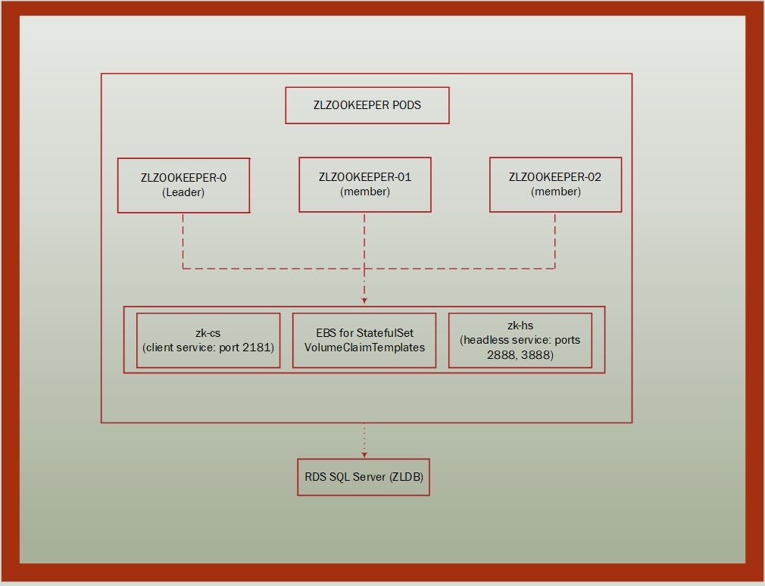
Figure 2: ZooKeeper Architecture

STEP 32: Create ZL Application Service Account

📋 Explanation
Creates a Kubernetes ServiceAccount for the ZL Application pods, providing identity and enabling RBAC controls.

💻 Code Block
All Shells:
kubectl create serviceaccount zlapp-sa -n default
Verify:
kubectl get serviceaccount zlapp-sa

STEP 33: Deploy ZooKeeper Services

📋 Explanation
Creates Kubernetes Services that provide network access to ZooKeeper pods - both for client connections and internal pod-to-pod communication.

⚙️ What It Does
- zk-cs (Client Service): ClusterIP service for application connections on port 2181
- zk-hs (Headless Service): Enables StatefulSet DNS for pod-to-pod communication

💻 Code Block
All Shells:
# Client service (for application connections)
kubectl apply -f yaml/zk-cs.yaml

# Headless service (for pod-to-pod communication)
kubectl apply -f yaml/zk-hs.yaml
Verify Services:
kubectl get services zk-cs zk-hs
Expected Output:
NAME TYPE CLUSTER-IP EXTERNAL-IP PORT(S) AGE
zk-cs ClusterIP 10.100.xxx.xxx <none> 2181/TCP 1m
zk-hs ClusterIP None <none> 2888/TCP,3888/TCP 1m
View YAML

STEP 34: Deploy Application ConfigMap

📋 Explanation
Creates a ConfigMap containing ZL Application configuration including ZooKeeper connection settings.

💻 Code Block
All Shells:
kubectl apply -f yaml/zlapp-config.yaml
Verify ConfigMap:
kubectl get configmap zlapp-config -o yaml
Key Configuration:
ZOO_SERVERS: "zlzookeeper-0.zk-hs.default.svc.cluster.local:2181,zlzookeeper-1.zk-hs.default.svc.cluster.local:2181,zlzookeeper-2.zk-hs.default.svc.cluster.local:2181"
View YAML

STEP 35: Deploy ZooKeeper StatefulSet

📋 Explanation
Deploys a 3-node ZooKeeper ensemble as a Kubernetes StatefulSet with persistent storage.

❓ Why It's Needed
ZooKeeper requires:
- Odd number of nodes: For quorum voting (3 nodes tolerates 1 failure)
- Stable identities: StatefulSet provides predictable pod names
- Persistent storage: EBS volumes survive pod restarts
- Ordered deployment: Pods start sequentially (0, then 1, then 2)

💻 Code Block
All Shells:
kubectl apply -f yaml/zlzookeeper-statefulset.yaml
Watch Pod Creation:
kubectl get pods -l app=zlzookeeper -w
View YAML

STEP 36: Verify ZooKeeper Deployment

📋 Explanation
Confirms all ZooKeeper pods are running and their persistent volumes are bound.

💻 Code Block
All Shells:
# Check pods
kubectl get pods -l app=zlzookeeper

# Check persistent volume claims
kubectl get pvc -l app=zlzookeeper
Expected Pod Output:
NAME READY STATUS RESTARTS AGE
zlzookeeper-0 1/1 Running 0 5m
zlzookeeper-1 1/1 Running 0 4m
zlzookeeper-2 1/1 Running 0 3m
Expected PVC Output:
NAME STATUS VOLUME CAPACITY ACCESS MODES STORAGECLASS
data-zlzookeeper-0 Bound pvc-xxxxx 10Gi RWO ebs-sc
data-zlzookeeper-1 Bound pvc-xxxxx 10Gi RWO ebs-sc
data-zlzookeeper-2 Bound pvc-xxxxx 10Gi RWO ebs-sc
Test ZooKeeper Connectivity:
kubectl exec zlzookeeper-0 -- zkCli.sh -server localhost:2181 ls /

PHASE 8: Application Deployment (zltika, zlserver, zlui)

Overview
This phase deploys the three main ZL Application components:
- zltika: Apache Tika-based document conversion service
- zlserver: Backend application server
- zlui: Web frontend user interface

Application Architecture
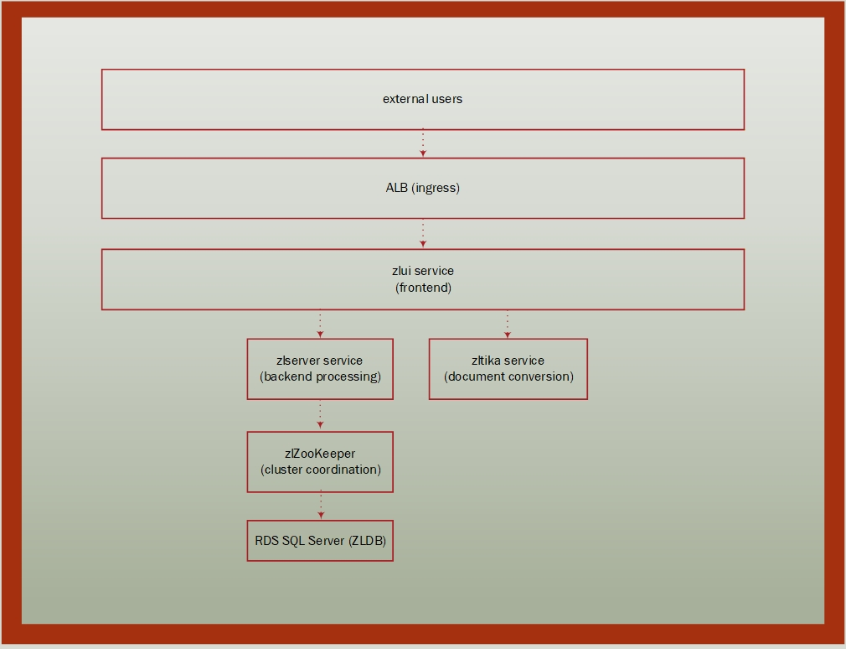
Figure 3: Application Architecture

Deployment Order
- Step 37: Document Conversion ConfigMap (Tika hostname override)
- Step 38: zltika deployment and service
- Step 39: zlserver deployment
- Step 40: zlui deployment and service
- Step 41-42: Verification

STEP 37: Deploy Tika Connection ConfigMap

📋 Explanation
Creates a ConfigMap containing the Tika service connection settings. This overrides the default localhost connection to point to the Kubernetes zltika service.

❓ Why It's Needed
In Kubernetes, each pod has its own localhost. The ZL Application defaults to connecting to Tika on localhost, which doesn't work when Tika runs in a separate pod. This ConfigMap provides the Kubernetes service name so zlserver/zlui can locate the zltika pods.
Note: Document conversion settings (file limits, extensions, OCR options, etc.) are managed by the zltika service itself via the application registry.

💻 Code Block
All Shells:
kubectl apply -f yaml/docconvert-configmap.yaml
Verify ConfigMap:
kubectl get configmap docconvert-config -o yaml
View YAML

STEP 38: Deploy Tika Service

📋 Explanation
Deploys the Apache Tika document conversion service that processes documents for text extraction and format conversion.

⚙️ What It Does
- Creates Deployment with Tika container image
- Creates ClusterIP Service on port 9998
- Mounts EFS volume for temporary file storage
- Configures resource limits (CPU/memory)

💻 Code Block
All Shells:
# Deploy Tika pod
kubectl apply -f yaml/zltika-deployment.yaml

# Create Tika service
kubectl apply -f yaml/zltika-service.yaml
Verify Deployment:
kubectl get deployment zltika
kubectl get service zltika
Expected Output:
NAME READY UP-TO-DATE AVAILABLE AGE
zltika 1/1 1 1 1m

NAME TYPE CLUSTER-IP EXTERNAL-IP PORT(S) AGE
zltika ClusterIP 10.100.xxx.xxx <none> 9998/TCP 1m
View YAML

STEP 39: Deploy ZL Server

📋 Explanation
Deploys the ZL Server backend application that handles business logic, database operations, and application services.

⚙️ What It Does
- Creates Deployment with zlserver container image
- Configures environment variables from ConfigMaps and Secrets
- Mounts EFS volumes for vault and logs
- Mounts DocumentConversion.xml ConfigMap
- Configures ZooKeeper connection

📌 Prerequisite Tasks
- Step 11: ECR pull secret in default namespace
- Step 24: EFS PVCs created (zlvault, zlserverlogs)
- Step 29-30: Database ConfigMap and Secret
- Step 34: Application ConfigMap (ZooKeeper settings)
- Step 35-36: ZooKeeper running and healthy
- Step 37: Document Conversion ConfigMap
- Step 38: Tika service deployed

💻 Code Block
All Shells:
kubectl apply -f yaml/zlserver-deployment.yaml
Watch Pod Startup:
kubectl get pods -l app=zlserver -w
Check Logs for Initialization:
kubectl logs deployment/zlserver -f
Expected Log Message:
Done initalizing ZLServer
View YAML

STEP 40: Deploy ZL UI

📋 Explanation
Deploys the ZL UI web frontend that provides the user interface for the application.

⚙️ What It Does
- Creates Deployment with zlui container (same image as zlserver)
- Creates ClusterIP Service on port 8080
- Configures environment variables for UI mode
- Mounts EFS volumes for vault, logs, and Tika temp
- Mounts DocumentConversion.xml ConfigMap

💻 Code Block
All Shells:
# Deploy UI pod
kubectl apply -f yaml/zlui-deployment.yaml

# Create UI service
kubectl apply -f yaml/zlui-service.yaml
Verify Deployment:
kubectl get deployment zlui
kubectl get service zlui-service
Expected Output:
NAME READY UP-TO-DATE AVAILABLE AGE
zlui 1/1 1 1 1m

NAME TYPE CLUSTER-IP EXTERNAL-IP PORT(S) AGE
zlui-service ClusterIP 10.100.xxx.xxx <none> 8080/TCP 1m
View YAML

STEP 41: Verify All Pods Running

📋 Explanation
Confirms all application pods are running and ready before proceeding with network configuration.

💻 Code Block
All Shells:
kubectl get pods -n default
Expected Output:
NAME READY STATUS RESTARTS AGE
zltika-xxxxxxxxxx-xxxxx 1/1 Running 0 10m
zlserver-xxxxxxxxxx-xxxxx 1/1 Running 0 8m
zlui-xxxxxxxxxx-xxxxx 1/1 Running 0 5m
zlzookeeper-0 1/1 Running 0 20m
zlzookeeper-1 1/1 Running 0 19m
zlzookeeper-2 1/1 Running 0 18m
Check for Issues:
# Pods not in Running state
kubectl get pods --field-selector=status.phase!=Running

# Describe pod for troubleshooting
kubectl describe pod <pod-name>

STEP 42: Verify Application Initialization

📋 Explanation
Checks application logs to confirm the ZL Application has fully initialized and is ready to serve requests.

❓ Why It's Needed
Pods may show "Running" status but the application inside may still be initializing. The application must complete initialization before it can serve user requests.

💻 Code Block
Bash PowerShell Windows CMD

Success Indicator:
Done initalizing ZLServer
Check All Logs:
# zlui logs
kubectl logs deployment/zlui --tail=100

# zlserver logs
kubectl logs deployment/zlserver --tail=100

# zltika logs
kubectl logs deployment/zltika --tail=100

PHASE 9: Network and Ingress Configuration

Overview
This phase configures the AWS Load Balancer Controller and creates an Ingress resource to expose the ZL Application to external users via an Application Load Balancer (ALB).

Why ALB Ingress Is Needed
- External Access: Makes the application accessible from the internet
- SSL/TLS Termination: Can handle HTTPS traffic (with ACM certificates)
- Load Balancing: Distributes traffic across multiple UI pods
- Health Checks: Automatically routes away from unhealthy pods
- AWS Integration: Native integration with AWS networking

Network Architecture
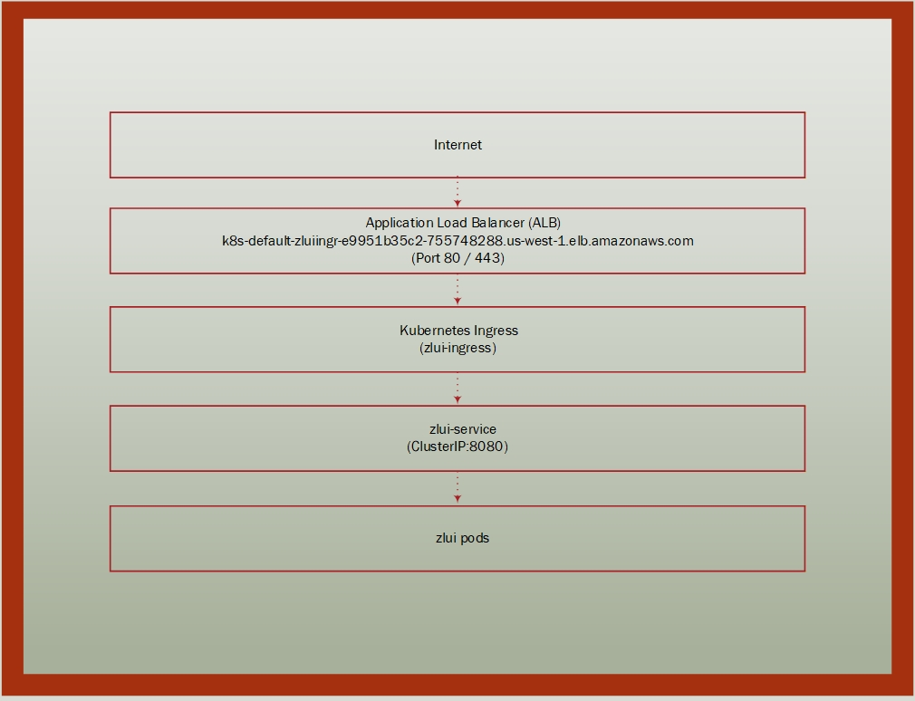
Figure 4: Network Architecture
2. Create IAM Policy:
aws iam create-policy --policy-name AWSLoadBalancerControllerIAMPolicy --policy-document file://iam-policy-alb.json --region us-west-1
View JSON

3. Create Service Account:
eksctl create iamserviceaccount --cluster=usw1-zlps-eks-01 --namespace=kube-system --name=aws-load-balancer-controller --attach-policy-arn=arn:aws:iam::995553364920:policy/AWSLoadBalancerControllerIAMPolicy --override-existing-serviceaccounts --approve --region us-west-1
4. Install cert-manager:
kubectl apply --validate=false -f https://github.com/jetstack/cert-manager/releases/download/v1.13.3/cert-manager.yaml
5. Add Helm Repository:
helm repo add eks https://aws.github.io/eks-charts
helm repo update
6. Install Controller via Helm:
PowerShell Bash Windows CMD

Verify Controller Installation:
kubectl get deployment -n kube-system aws-load-balancer-controller

STEP 44: Create Ingress for Public Access

📋 Explanation
Creates a Kubernetes Ingress resource that defines how external traffic should be routed to the zlui service.

⚙️ What It Does
- Creates Ingress resource with ALB annotations
- Configures ALB as internet-facing load balancer
- Routes all HTTP traffic to zlui-service on port 8080
- Triggers ALB creation by the Load Balancer Controller

💻 Code Block
All Shells:
kubectl apply -f yaml/zlui-ingress.yaml
Verify Ingress Created:
kubectl get ingress zlui-ingress
View YAML

STEP 45: Verify Ingress and ALB

📋 Explanation
Confirms the Ingress resource was created and the ALB was provisioned with a public DNS name.

💻 Code Block
All Shells:
kubectl get ingress zlui-ingress
Expected Output:
NAME CLASS HOSTS ADDRESS PORTS AGE
zlui-ingress alb * k8s-default-zluiingr-e9951b35c2-755748288.us-west-1.elb.amazonaws.com 80 5m
Access URL:
http://k8s-default-zluiingr-e9951b35c2-755748288.us-west-1.elb.amazonaws.com
Verify ALB in AWS Console:
aws elbv2 describe-load-balancers --region us-west-1 --query "LoadBalancers[?contains(LoadBalancerName, 'k8s-default-zluiingr')]"
Note: It may take 2-5 minutes for the ALB to become active and DNS to propagate.

PHASE 10: Cluster Autoscaling Optional

Overview
Cluster Autoscaler automatically adjusts the number of nodes in your EKS node group based on pod resource requests. When pods can't be scheduled due to insufficient resources, the autoscaler adds nodes. When nodes are underutilized, it removes them.

Why Autoscaling Is Needed
- Cost Optimization: Scale down during low usage periods
- Availability: Scale up when demand increases
- Automation: No manual intervention required
- Resource Efficiency: Match capacity to actual workload

STEP 46: Create Cluster Autoscaler IAM Policy

📋 Explanation
Creates an IAM policy that grants the Cluster Autoscaler permissions to modify Auto Scaling Groups.

💻 Code Block
All Shells:
aws iam create-policy --policy-name AmazonEKSClusterAutoscalerPolicy --policy-document file://policies/ClusterAutoscalerPolicy.json --region us-west-1
View JSON

STEP 47: Create Service Account for Autoscaler

📋 Explanation
Creates a Kubernetes service account with IAM role permissions for the Cluster Autoscaler.

💻 Code Block
All Shells:
eksctl create iamserviceaccount --cluster usw1-zlps-eks-01 --region us-west-1 --namespace kube-system --name cluster-autoscaler --attach-policy-arn arn:aws:iam::995553364920:policy/AmazonEKSClusterAutoscalerPolicy --approve --override-existing-serviceaccounts

STEP 48: Tag ASG for Cluster Autoscaler Discovery

📋 Explanation
Adds tags to the Auto Scaling Group that enable the Cluster Autoscaler to discover and manage it.

💻 Code Block
PowerShell Bash

Note: Replace the ASG ResourceId with your actual ASG name from the EKS console.

STEP 49: Update Node Group Scaling Limits

📋 Explanation
Updates the node group's minimum and maximum node counts to allow the autoscaler to scale within the desired range.

💻 Code Block
All Shells:
eksctl scale nodegroup --cluster usw1-zlps-eks-01 --name uw1-zlps-ng-01 --nodes-min 2 --nodes-max 5 --nodes 2 --region us-west-1
Verify:
eksctl get nodegroup --cluster usw1-zlps-eks-01 --region us-west-1

STEP 50: Deploy Cluster Autoscaler

📋 Explanation
Deploys the Cluster Autoscaler as a Kubernetes Deployment that monitors pod scheduling and adjusts node count.

💻 Code Block
All Shells:
kubectl apply -f yaml/cluster-autoscaler.yaml
Verify Deployment:
kubectl get deployment cluster-autoscaler -n kube-system
kubectl logs -n kube-system deployment/cluster-autoscaler --tail=50

PHASE 11: Post-Deployment Configuration

Overview
This phase completes the deployment by creating required directory structures in the vault, updating database configurations, and restarting deployments to apply changes.

STEP 51: Create Vault Directory Structure

📋 Explanation
Creates all required subdirectories in the EFS-mounted vault with correct naming (case-sensitive).

❓ Why It's Needed
The ZL Application expects specific directories to exist in the vault for document storage, search indexes, log events, and more. Linux/EFS is case-sensitive.

💻 Code Block
All Shells (runs bash inside Linux container):
kubectl exec deployment/zlui -- bash -c 'mkdir -p /var/ZipLip/Vault/{resource,secureResource,zlreport,zlexport,zlperiodic,staging,zlSecureMail,zlArchiveMail,zlArchiveAttach,zlJournalMail,zlJournalAttach,zlSearch,zlSearchMaster,zlSearchOther,zlFileRegular,zlFileSearch,zlFileSearchMaster,zlFileSearchOther,zlCompliance,zlCaseMgmt,zlCcPackage,zlRecord,zlTextDBTemp,zlTextDBMaster,zlBigDBApps,zlLogEvent,zlLogEventSearchMaster,zlLogEventSearch,zlInPlaceWorkspaceIndex,zlInPlaceMailContent,zlInPlaceFileRegular}'

STEP 52: Verify Vault Structure

📋 Explanation
Confirms all vault directories were created with correct names and permissions.

💻 Code Block
All Shells:
kubectl exec deployment/zlui -- ls -la /var/ZipLip/Vault/
Count Directories:
kubectl exec deployment/zlui -- bash -c 'ls -d /var/ZipLip/Vault/*/ | wc -l'
Expected: 31 directories

STEP 53: Update Database Disk Volume Paths

📋 Explanation
Updates the diskvolume table in the database to reflect the new EFS mount paths used in Kubernetes.

❓ Why It's Needed
The database contains paths to vault directories. When migrating to Kubernetes with EFS, these paths change from the original installation paths to the new mount point (/var/ZipLip/Vault/).

💻 Code Block
SQL (run via SSMS or sqlcmd):
-- View current paths
SELECT dvid, dvpath FROM diskvolume WHERE dvpath LIKE '%ZLVault%';

-- Update paths to new mount point
UPDATE diskvolume
SET dvpath = REPLACE(dvpath, '/zlvault/Archive_Vault/ZLVault/', '/var/ZipLip/Vault/')
WHERE dvpath LIKE '/zlvault/Archive_Vault/ZLVault/%';

-- Verify update
SELECT dvid, dvpath FROM diskvolume;
Note: Adjust the source path pattern to match your original installation paths.

STEP 54: Restart Deployments After Configuration Changes

📋 Explanation
Restarts all application deployments to ensure they pick up the latest configuration changes and reconnect to updated resources.

💻 Code Block
All Shells:
kubectl rollout restart deployment zlserver zltika zlui
Watch Rollout Status:
kubectl rollout status deployment zlui
kubectl rollout status deployment zlserver
kubectl rollout status deployment zltika
Verify All Pods Running:
kubectl get pods -n default

Troubleshooting

Overview
This section provides solutions for common issues encountered during ZL Application deployment on AWS EKS. Each issue includes symptoms, root cause analysis, and resolution steps.

Issue 1: Tika Connectivity Error

Symptoms
- Error message: "Unable to connect!" or "Thread has already exited"
- Document conversion fails
- zlserver/zlui logs show Tika connection timeout

Root Cause
The ZL Application is configured to connect to Tika on localhost, but in Kubernetes each pod has its own localhost. The DocumentConversion.xml ConfigMap must override the hostname to use the Kubernetes service name.

Resolution
# Step 1: Verify ConfigMap exists
kubectl get configmap docconvert-config

# Step 2: Apply ConfigMap if missing
kubectl apply -f yaml/docconvert-configmap.yaml

# Step 3: Verify ConfigMap is mounted in deployments
kubectl describe deployment zlui | grep -A5 "Mounts:"
kubectl describe deployment zlserver | grep -A5 "Mounts:"

# Step 4: Restart deployments
kubectl rollout restart deployment zlserver zlui

# Step 5: Verify Tika service is accessible
kubectl exec deployment/zlui -- curl -s http://zltika:9998/tika

Issue 2: Database Connection Issues

Symptoms
- Error message: "Login failed for user"
- Application fails to start
- zlui shows 500 error on login

Root Cause
Database credentials are incorrect, or the RDS endpoint is unreachable from the EKS cluster.

Resolution
# Step 1: Verify database ConfigMap
kubectl get configmap db-config -o yaml

# Step 2: Verify database Secret exists
kubectl get secret db-secret

# Step 3: Test database connectivity from a pod
kubectl exec deployment/zlui -- bash -c 'nc -zv usw1-zlps-msexpsql-01-eks.c5s06occm2dn.us-west-1.rds.amazonaws.com 1433'

# SQL: Verify pfuser exists (via SSMS)
SELECT name, type_desc FROM sys.database_principals WHERE name = 'pfuser';

# SQL: Reset password if needed
ALTER LOGIN pfuser WITH PASSWORD = 'NewPassword';

# Step 4: Update Kubernetes secret and restart
kubectl apply -f yaml/zldb-secret.yaml
kubectl rollout restart deployment zlserver zlui

Issue 3: ZooKeeper Not Ready

Symptoms
- Error message: "null instance" in zlui logs
- Application shows 404 error
- ZooKeeper pods not all Running

Root Cause
ZooKeeper ensemble is not healthy, or the application cannot connect to ZooKeeper services.

Resolution
# Step 1: Check ZooKeeper pod status
kubectl get pods -l app=zlzookeeper

# Step 2: Check ZooKeeper logs
kubectl logs zlzookeeper-0
kubectl logs zlzookeeper-1
kubectl logs zlzookeeper-2

# Step 3: Verify ZooKeeper service endpoints
kubectl get endpoints zk-cs

# Expected Output:
# NAME ENDPOINTS AGE
# zk-cs 10.0.x.x:2181,10.0.y.y:2181,10.0.z.z:2181 1d

# Step 4: Verify zlapp-config has correct ZOO_SERVERS
kubectl get configmap zlapp-config -o yaml | grep ZOO_SERVERS

# Step 5: Test ZooKeeper connectivity
kubectl exec zlzookeeper-0 -- zkCli.sh -server localhost:2181 ls /
If ZooKeeper data is corrupted, delete PVCs and redeploy (WARNING: This deletes ZooKeeper data!):
kubectl delete statefulset zlzookeeper
kubectl delete pvc -l app=zlzookeeper
kubectl apply -f yaml/zlzookeeper-statefulset.yaml

Issue 4: Image Pull Errors

Symptoms
- Pod status: ImagePullBackOff or ErrImagePull
- Error: unauthorized: authentication required
- New pods fail to start

Root Cause
ECR authentication tokens expire after 12 hours. The docker-secret needs to be refreshed.

Resolution
PowerShell Bash

Issue 5: EFS Mount Failures

Symptoms
- Pod status: ContainerCreating for extended time
- Error: MountVolume.SetUp failed
- Events show mount.nfs: Connection timed out

Root Cause
EFS mount targets don't exist in the node's availability zone, or security groups block NFS traffic (port 2049).

Resolution
# Step 1: Verify mount targets exist
aws efs describe-mount-targets --file-system-id fs-0a4ec87cd91178047 --region us-west-1

# Step 2: Check mount target availability zones
# Both us-west-1a and us-west-1c should have mount targets

# Step 3: Create missing mount target
# For us-west-1a
aws efs create-mount-target --file-system-id fs-0a4ec87cd91178047 --subnet-id subnet-01c24772a882a3a1b --security-groups sg-0afb0a3f0c30ba84d --region us-west-1

# For us-west-1c
aws efs create-mount-target --file-system-id fs-0a4ec87cd91178047 --subnet-id subnet-06eb80d784d985109 --security-groups sg-0afb0a3f0c30ba84d --region us-west-1

# Step 4: Verify security group allows NFS
aws ec2 describe-security-groups --group-ids sg-0afb0a3f0c30ba84d --query "SecurityGroups[].IpPermissions[?FromPort==\`2049\`]" --region us-west-1

# Step 5: Add NFS rule if missing
aws ec2 authorize-security-group-ingress --group-id sg-0afb0a3f0c30ba84d --protocol tcp --port 2049 --source-group sg-0afb0a3f0c30ba84d --region us-west-1

# Step 6: Verify PV access point IDs match
kubectl get pv -o yaml | grep -A2 "volumeHandle"

Issue 6: 404 Error on Application

Symptoms
- Browser shows 404 - Page not found
- Application loads but routes fail
- Login page not displayed

Root Cause
ZooKeeper bootstrap has not completed, or the application hasn't fully initialized.

Resolution
# Step 1: Check ZooKeeper status
kubectl get pods -l app=zlzookeeper
# All 3 pods should be Running with 1/1 ready

# Step 2: Check zlui initialization logs
kubectl logs deployment/zlui | grep -i "initializing\|done\|error"

# Step 3: Wait for initialization (can take 2-5 minutes on first start)

# Step 4: Restart zlui if stuck
kubectl rollout restart deployment zlui

# Step 5: Check for database initialization
kubectl logs deployment/zlui | grep -i "database\|connection"

Issue 7: 500 Access Denied Error

Symptoms
- Error: 500 - Internal Server Error
- Message from ZLJspFilter
- Application partially loads then fails

Root Cause
Application not fully initialized, or database permissions issue.

Resolution
# Step 1: Check all pods are running
kubectl get pods -n default

# Step 2: Verify database connectivity
kubectl logs deployment/zlui | grep -i "database\|connection\|error"

# SQL: Check pfuser has db_owner role (via SSMS)
EXEC sp_helpuser 'pfuser';
-- Should show db_owner role

# SQL: Grant db_owner if missing
USE ZLDB;
EXEC sp_addrolemember 'db_owner', 'pfuser';

# Step 3: Restart application
kubectl rollout restart deployment zlui zlserver

Issue 8: Pods Stuck in Pending State

Symptoms
- Pod status: Pending
- Events show: FailedScheduling
- Message: Insufficient cpu or Insufficient memory

Root Cause
Not enough node resources to schedule the pod, or node group has reached maximum capacity.

Resolution
# Step 1: Check pod events
kubectl describe pod <pod-name> | grep -A10 Events

# Step 2: Check node resources
kubectl describe nodes | grep -A5 "Allocated resources"

# Step 3: Scale node group
eksctl scale nodegroup --cluster usw1-zlps-eks-01 --name uw1-zlps-ng-01 --nodes 3 --region us-west-1

# Step 4: If autoscaler is configured, check its logs
kubectl logs -n kube-system deployment/cluster-autoscaler --tail=50

Issue 9: ALB Not Created / Ingress Has No Address

Symptoms
- kubectl get ingress shows empty ADDRESS field
- ALB not visible in AWS console
- External access not working

Root Cause
AWS Load Balancer Controller is not running, or Ingress annotations are incorrect.

Resolution
# Step 1: Check Load Balancer Controller
kubectl get deployment -n kube-system aws-load-balancer-controller
kubectl logs -n kube-system deployment/aws-load-balancer-controller --tail=50

# Step 2: Check Ingress events
kubectl describe ingress zlui-ingress

# Step 3: Verify Ingress annotations
kubectl get ingress zlui-ingress -o yaml | grep -A10 annotations

# Required annotations:
# kubernetes.io/ingress.class: alb
# alb.ingress.kubernetes.io/scheme: internet-facing
# alb.ingress.kubernetes.io/target-type: ip

# Step 4: Reinstall Load Balancer Controller if needed (see Step 43)

Issue 10: Data Written to Container Instead of EFS

Symptoms
- Files disappear after pod restart
- Logs show files created but not visible after restart
- Vault directories empty after pod recreation

Root Cause
Volume mounts are not configured in the deployment YAML, so data is written to the container's ephemeral filesystem instead of the persistent EFS volume.

Resolution
# Step 1: Verify volume mounts in deployment
kubectl describe deployment zlui | grep -A20 "Mounts:"
kubectl describe deployment zlserver | grep -A20 "Mounts:"

# Step 2: Check PVC is bound
kubectl get pvc
# All PVCs should show "Bound" status

# Step 3: Verify volumeMounts in YAML (should have):
# volumeMounts:
# - name: zlvault-efs
# mountPath: /var/ZipLip/Vault
#
# volumes:
# - name: zlvault-efs
# persistentVolumeClaim:
# claimName: efs-pvc-zlvault

# Step 4: Update deployment YAML and reapply
kubectl apply -f yaml/zlui-deployment.yaml
kubectl apply -f yaml/zlserver-deployment.yaml
Warning: Data written to container storage before the mount was configured is NOT recoverable. Always verify mounts before processing important data.

Quick Reference: Useful Diagnostic Commands
# Pod status and events
kubectl get pods -n default
kubectl describe pod <pod-name>

# Deployment logs
kubectl logs deployment/zlui --tail=100
kubectl logs deployment/zlserver --tail=100
kubectl logs deployment/zltika --tail=100

# ZooKeeper logs
kubectl logs zlzookeeper-0 --tail=100

# Check all services
kubectl get services

# Check endpoints
kubectl get endpoints

# Check PV/PVC status
kubectl get pv
kubectl get pvc

# Check ConfigMaps
kubectl get configmaps

# Check Secrets
kubectl get secrets

# Node status
kubectl get nodes
kubectl describe nodes

# Resource usage
kubectl top pods
kubectl top nodes

Appendix A: YAML File Reference

Overview
This appendix contains the complete YAML files used in the ZL Application deployment. All files are located in the yaml/ directory.

Volume Mount Summary
Pod | Vault Access | Logs Access | Temp Access | DocConvert ConfigMap
zlui | zlvault | zluilogs | zltikatemp | Yes
zlserver | zlvault | zlserverlogs | zlservertemp | Yes
zltika | No | No | zltikatemp | No
zookeeper | No | No | No (uses EBS) | No

A.1 zlui-deployment.yaml - ZL UI Application
Purpose: Deploys the web UI for ZL application
Image: zlserver-11.0.1-b123 (shared with zlserver)
Replicas: 1
apiVersion: apps/v1
kind: Deployment
metadata:
labels:
name: zlui
name: zlui
spec:
replicas: 1
selector:
matchLabels:
app: zlui
strategy:
type: Recreate
template:
metadata:
labels:
app: zlui
spec:
serviceAccountName: zlapp-sa
imagePullSecrets:
- name: docker-secret
containers:
- name: zlui
image: 995553364920.dkr.ecr.us-west-1.amazonaws.com/uw1-zlps-ecr-01:zlserver-11.0.1-b123
imagePullPolicy: Always
resources:
limits:
cpu: 500m
memory: 1Gi
requests:
cpu: 500m
memory: 1Gi
env:
- name: CLUSTER_NAME
value: ZLUI
- name: INITIAL_EXECUTORS
value: "5"
- name: SERVICE_EXECUTORS
value: "5"
- name: MANAGED_EXECUTORS
value: "5"
envFrom:
- configMapRef:
name: zlapp-config
- configMapRef:
name: db-config
- secretRef:
name: db-secret
volumeMounts:
- mountPath: /opt/ZipLip/zlserver/WEB-INF/tmp
name: zltikatemp
- mountPath: /opt/ZipLip/logs
name: zluilogs
- mountPath: /var/ZipLip/Vault
name: zlvault
- mountPath: /opt/ZipLip/zlserver/WEB-INF/config/app/sheet/DocumentConversion.xml
name: docconvert-config
subPath: DocumentConversion.xml
restartPolicy: Always
volumes:
- name: zltikatemp
persistentVolumeClaim:
claimName: zltikatemp-efs
- name: zluilogs
persistentVolumeClaim:
claimName: zluilogs-efs
- name: zlvault
persistentVolumeClaim:
claimName: zlvault-efs
- name: docconvert-config
configMap:
name: docconvert-config

A.2 zlserver-deployment.yaml - ZL Server Backend
Purpose: Backend processing server
Image: zlserver-11.0.1-b123
Replicas: 1
apiVersion: apps/v1
kind: Deployment
metadata:
labels:
name: zlserver
name: zlserver
spec:
replicas: 1
selector:
matchLabels:
app: zlserver
strategy:
type: Recreate
template:
metadata:
labels:
app: zlserver
spec:
serviceAccountName: zlapp-sa
imagePullSecrets:
- name: docker-secret
containers:
- name: zlserver
image: 995553364920.dkr.ecr.us-west-1.amazonaws.com/uw1-zlps-ecr-01:zlserver-11.0.1-b123
imagePullPolicy: Always
resources:
limits:
cpu: 250m
memory: 500Mi
requests:
cpu: 100m
memory: 256Mi
ports:
- containerPort: 9972
envFrom:
- configMapRef:
name: db-config
- configMapRef:
name: zlapp-config
- secretRef:
name: db-secret
volumeMounts:
- mountPath: /opt/ZipLip/zlserver/WEB-INF/tmp
name: zlservertemp
- mountPath: /opt/ZipLip/zlserver/WEB-INF/config/app/sheet/DocumentConversion.xml
name: docconvert-config
subPath: DocumentConversion.xml
- mountPath: /opt/ZipLip/logs
name: zlserverlogs
- mountPath: /var/ZipLip/Vault
name: zlvault
volumes:
- name: zlservertemp
persistentVolumeClaim:
claimName: zlservertemp-efs
- name: docconvert-config
configMap:
name: docconvert-config
- name: zlserverlogs
persistentVolumeClaim:
claimName: zlserverlogs-efs
- name: zlvault
persistentVolumeClaim:
claimName: zlvault-efs

A.3 zltika-deployment.yaml - Document Conversion Service
Purpose: Apache Tika-based document conversion
Image: zltika-11.0.1-b123
Replicas: 1
apiVersion: apps/v1
kind: Deployment
metadata:
labels:
name: zltika
name: zltika
spec:
replicas: 1
selector:
matchLabels:
app: zltika
strategy:
type: Recreate
template:
metadata:
labels:
app: zltika
spec:
serviceAccountName: zlapp-sa
imagePullSecrets:
- name: docker-secret
containers:
- name: zltika
image: 995553364920.dkr.ecr.us-west-1.amazonaws.com/uw1-zlps-ecr-01:zltika-11.0.1-b123
imagePullPolicy: Always
resources:
limits:
cpu: 250m
memory: 500Mi
requests:
cpu: 100m
memory: 256Mi
ports:
- containerPort: 9972
volumeMounts:
- mountPath: /opt/ZipLip/zlserver/WEB-INF/tmp
name: zltikatemp
volumes:
- name: zltikatemp
persistentVolumeClaim:
claimName: zltikatemp-efs

A.4 zltika-service.yaml - Tika Service
apiVersion: v1
kind: Service
metadata:
labels:
app: zltika
name: zltika
spec:
ports:
- name: "9972"
port: 9972
targetPort: 9972
selector:
app: zltika

A.5 zlzookeeper-statefulset.yaml - ZooKeeper Cluster
Purpose: Distributed coordination service
Image: zlzookeeper-11.0.1-b123
Replicas: 3 (for quorum)
apiVersion: apps/v1
kind: StatefulSet
metadata:
name: zlzookeeper
labels:
app: zlzookeeper
spec:
serviceName: zk-hs
replicas: 3
selector:
matchLabels:
app: zlzookeeper
template:
metadata:
labels:
app: zlzookeeper
spec:
serviceAccountName: zlapp-sa
imagePullSecrets:
- name: docker-secret
containers:
- name: zlzookeeper
image: 995553364920.dkr.ecr.us-west-1.amazonaws.com/uw1-zlps-ecr-01:zlzookeeper-11.0.1-b123
imagePullPolicy: Always
envFrom:
- configMapRef:
name: zlapp-config
ports:
- containerPort: 2181
name: client
- containerPort: 2888
name: peer
- containerPort: 3888
name: election
resources:
limits:
cpu: 500m
memory: 2Gi
requests:
cpu: 200m
memory: 500Mi
volumeMounts:
- name: zlzkdata
mountPath: /var/ZipLip/DATA/ZooKeeper
restartPolicy: Always
volumeClaimTemplates:
- metadata:
name: zlzkdata
spec:
accessModes: ["ReadWriteOnce"]
storageClassName: ebs-sc
resources:
requests:
storage: 10Gi

A.6 ZooKeeper Services

zk-cs.yaml - ZooKeeper Client Service
apiVersion: v1
kind: Service
metadata:
name: zk-cs
labels:
app: zlzookeeper
spec:
ports:
- port: 2181
name: client
selector:
app: zlzookeeper

zk-hs.yaml - ZooKeeper Headless Service
apiVersion: v1
kind: Service
metadata:
labels:
app: zlzookeeper
name: zk-hs
spec:
ports:
- port: 2888
name: server
- port: 3888
name: leader-election
clusterIP: None
selector:
app: zlzookeeper

A.7 zlui-ingress.yaml - Public ALB Ingress
apiVersion: networking.k8s.io/v1
kind: Ingress
metadata:
name: zlui-ingress
annotations:
alb.ingress.kubernetes.io/scheme: internet-facing
alb.ingress.kubernetes.io/target-type: ip
alb.ingress.kubernetes.io/subnets: subnet-01c24772a882a3a1b,subnet-06eb80d784d985109
alb.ingress.kubernetes.io/listen-ports: '[{"HTTP": 80}]'
alb.ingress.kubernetes.io/healthcheck-path: /
alb.ingress.kubernetes.io/healthcheck-protocol: HTTP
alb.ingress.kubernetes.io/healthcheck-port: traffic-port
spec:
ingressClassName: alb
rules:
- http:
paths:
- path: /
pathType: Prefix
backend:
service:
name: zlui
port:
number: 80

A.8 EFS StorageClass
apiVersion: storage.k8s.io/v1
kind: StorageClass
metadata:
name: efs-sc
provisioner: efs.csi.aws.com
parameters:
provisioningMode: efs-ap
fileSystemId: fs-0a4ec87cd91178047
directoryPerms: "755"
gidRangeStart: "1000"
gidRangeEnd: "2000"
basePath: "/dynamic_provisioning"

A.9 EBS StorageClass
apiVersion: storage.k8s.io/v1
kind: StorageClass
metadata:
name: ebs-sc
provisioner: ebs.csi.aws.com
parameters:
type: gp3
fsType: ext4
volumeBindingMode: WaitForFirstConsumer
allowVolumeExpansion: true

A.10 EFS PersistentVolume Example (zlvault)
apiVersion: v1
kind: PersistentVolume
metadata:
name: efs-pv-zlvault
spec:
capacity:
storage: 100Gi
volumeMode: Filesystem
accessModes:
- ReadWriteMany
persistentVolumeReclaimPolicy: Retain
storageClassName: efs-sc
csi:
driver: efs.csi.aws.com
volumeHandle: fs-0a4ec87cd91178047::fsap-070de74811e8c461f

A.11 EFS PersistentVolumeClaim Example (zlvault)
apiVersion: v1
kind: PersistentVolumeClaim
metadata:
name: zlvault-efs
namespace: default
spec:
accessModes:
- ReadWriteMany
storageClassName: efs-sc
resources:
requests:
storage: 100Gi
volumeName: efs-pv-zlvault

Appendix B: EFS Access Points and Vault Mount Structure

B.1 EFS File System Details
Property | Value
File System ID | fs-0a4ec87cd91178047
Name | usw1-zlps-efs-01
Region | us-west-1
Performance | General Purpose
Throughput | Bursting

B.2 EFS Access Points
Access Point ID | Name | Root Path | UID/GID | Permissions | Used By
fsap-070de74811e8c461f | zlvault-ap | /zlvault | 1000/1000 | 755 | zlui, zlserver
fsap-06e5e523915353e85 | zluilogs-ap | /zluilogs | 1000/1000 | 755 | zlui
fsap-0e3cf05f6ae8f8a82 | zlserverlogs-ap | /zlserverlogs | 1000/1000 | 755 | zlserver
fsap-08c3382b23a64f7fd | zltikatemp-ap | /zltikatemp | 1000/1000 | 755 | zltika, zlui, zlserver

B.3 Vault Directory Structure
The following directories must exist in /var/ZipLip/Vault/ with exact case-sensitive naming:

/var/ZipLip/Vault/
├── resource/ # General resources
├── secureResource/ # Secure resources
├── staging/ # Processing staging area
├── zlreport/ # Report generation
├── zlexport/ # Data export
├── zlperiodic/ # Periodic processing
├── zlSecureMail/ # Secure mail storage
├── zlArchiveMail/ # Archived email messages
├── zlArchiveAttach/ # Archived email attachments
├── zlJournalMail/ # Journal email messages
├── zlJournalAttach/ # Journal email attachments
├── zlSearch/ # Search index data
├── zlSearchMaster/ # Master search index
├── zlSearchOther/ # Additional search data
├── zlFileRegular/ # Regular file storage
├── zlFileSearch/ # File search index
├── zlFileSearchMaster/ # Master file search index
├── zlFileSearchOther/ # Additional file search data
├── zlCompliance/ # Compliance data
├── zlCaseMgmt/ # Case management files
├── zlCcPackage/ # CC package storage
├── zlRecord/ # Records management
├── zlTextDBTemp/ # Temporary text database
├── zlTextDBMaster/ # Master text database
├── zlBigDBApps/ # Large database applications
├── zlLogEvent/ # Log event storage
├── zlLogEventSearchMaster/ # Log event search master index
├── zlLogEventSearch/ # Log event search index
├── zlInPlaceWorkspaceIndex/ # In-place workspace indexing
├── zlInPlaceMailContent/ # In-place mail content
└── zlInPlaceFileRegular/ # In-place regular files

Total: 31 directories

Important: Directory names are case-sensitive on Linux/EFS! Names must match exactly.

Appendix C: ConfigMaps and Secrets

C.1 zlapp-config - Application Configuration
Purpose: ZooKeeper connection settings and Tika service configuration
Used By: zlui, zlserver, zlzookeeper
apiVersion: v1
kind: ConfigMap
metadata:
name: zlapp-config
namespace: default
data:
ZOO_SERVERS: zlzookeeper-0.zk-hs.default.svc.cluster.local:2181,zlzookeeper-1.zk-hs.default.svc.cluster.local:2181,zlzookeeper-2.zk-hs.default.svc.cluster.local:2181
TIKA_HOST: zltika
TIKA_PORT: "9972"
__tika.ZLTikaService.Host: zltika
__tika.ZLTikaService.Port: "9972"
DEFAULT_URL: ps/PmApp/zlp_dummy?mgc=1&NextPage=/app/home.jsp&domain=yourdomain.com&la=en&authMethod=ZipLipDB&resId=trac_login

C.2 db-config - Database Configuration
Purpose: RDS SQL Server connection settings (non-sensitive)
Used By: zlui, zlserver
apiVersion: v1
kind: ConfigMap
metadata:
name: db-config
namespace: default
data:
DB_HOST: "usw1-zlps-msexpsql-01-eks.c5s06occm2dn.us-west-1.rds.amazonaws.com"
DB_NAME: ZLDB
DB_PORT: "1433"
DB_TYPE: mssql
DB_USER: pfuser

C.3 db-secret - Database Credentials
Purpose: Secure storage of database password
Used By: zlui, zlserver
apiVersion: v1
kind: Secret
metadata:
name: db-secret
namespace: default
type: Opaque
data:
DB_PASSWORD: <BASE64_ENCODED_PASSWORD>

C.4 docconvert-config - Document Conversion Settings
Purpose: Override DocumentConversion.xml to use Kubernetes service name for Tika
Used By: zlui, zlserver (mounted as file)
Key Override:
<Bean>
<BeanName>__tika.ZLTikaService.Host</BeanName>
<BeanValue>zltika</BeanValue> <!-- Changed from localhost -->
</Bean>

<Bean>
<BeanName>__tika.ZLTikaService.Port</BeanName>
<BeanValue>9972</BeanValue>
</Bean>
Why This Is Critical: In Kubernetes, each pod has its own localhost. Without this override, zlui/zlserver would try to connect to Tika on localhost (themselves) instead of the zltika service.

Appendix D: Services and Networking

D.1 Kubernetes Services Summary
Service Name | Type | Ports | Selector | Purpose
zk-cs | ClusterIP | 2181 | app=zlzookeeper | ZooKeeper client connections
zk-hs | Headless | 2888, 3888 | app=zlzookeeper | ZooKeeper peer discovery
zltika | ClusterIP | 9972 | app=zltika | Document conversion service
zlui | LoadBalancer | 80, 8000, 9975, 9970 | app=zlui | UI access (internal LB)

D.2 DNS Resolution
Kubernetes DNS automatically resolves service names within the cluster:
DNS Name | Resolves To
zltika | zltika service ClusterIP
zltika.default.svc.cluster.local | zltika service ClusterIP (FQDN)
zlui | zlui service ClusterIP
zk-cs | ZooKeeper client service IP
zlzookeeper-0.zk-hs.default.svc.cluster.local | ZooKeeper pod 0 IP (stable)
zlzookeeper-1.zk-hs.default.svc.cluster.local | ZooKeeper pod 1 IP (stable)
zlzookeeper-2.zk-hs.default.svc.cluster.local | ZooKeeper pod 2 IP (stable)

D.3 Port Reference
Service/Pod | Port | Protocol | Purpose
zlui | 80 | HTTP | Web UI access
zlui | 8000 | TCP | Additional UI port
zlui | 9975 | TCP | File Connector
zlui | 9970 | TCP | SharePoint
zlserver | 9972 | TCP | Backend service
zltika | 9972 | TCP | Document conversion
zlzookeeper | 2181 | TCP | Client connections
zlzookeeper | 2888 | TCP | Peer communication
zlzookeeper | 3888 | TCP | Leader election
RDS | 1433 | TCP | SQL Server
EFS | 2049 | NFS | File system mount

D.4 External Access URLs
Resource | URL/Endpoint
Application | http://k8s-default-zluiingr-e9951b35c2-755748288.us-west-1.elb.amazonaws.com
EKS Cluster | usw1-zlps-eks-01.us-west-1.eks.amazonaws.com
ECR Repository | 995553364920.dkr.ecr.us-west-1.amazonaws.com/uw1-zlps-ecr-01
RDS Database | usw1-zlps-msexpsql-01-eks.c5s06occm2dn.us-west-1.rds.amazonaws.com:1433

Appendix E: Secure Deployment (No Internet Access)

E.1 Overview
This appendix describes the secure deployment configuration that restricts external internet access to the ZL Application. In this configuration:
- The Application Load Balancer (ALB) is configured as internal instead of internet-facing
- Access is restricted to users within the VPC or connected via VPN/Direct Connect
- No public IP addresses are exposed
- All traffic remains within the AWS private network

E.2 Architecture Changes
Component | Standard Deployment | Secure Deployment
ALB Scheme | internet-facing | internal
ALB Subnets | Public Subnets | Private Subnets
Access Method | Direct Internet Access | VPN / Direct Connect / Bastion
DNS Resolution | Public DNS | Private DNS (internal VPC)
Security Groups | Allow 0.0.0.0/0 on port 80/443 | Allow only VPC CIDR or specific IPs

E.3 Modified Ingress YAML
Replace the standard zlui-ingress.yaml with this secure version:
apiVersion: networking.k8s.io/v1
kind: Ingress
metadata:
name: zlui-ingress
annotations:
# Internal ALB - not accessible from internet
alb.ingress.kubernetes.io/scheme: internal
alb.ingress.kubernetes.io/target-type: ip
# Use PRIVATE subnets instead of public
alb.ingress.kubernetes.io/subnets: subnet-private-1a,subnet-private-1b
alb.ingress.kubernetes.io/listen-ports: '[{"HTTP": 80}, {"HTTPS": 443}]'
alb.ingress.kubernetes.io/healthcheck-path: /
alb.ingress.kubernetes.io/healthcheck-protocol: HTTP
# Restrict to VPC CIDR only
alb.ingress.kubernetes.io/inbound-cidrs: "10.0.0.0/16"
spec:
ingressClassName: alb
rules:
- http:
paths:
- path: /
pathType: Prefix
backend:
service:
name: zlui-service
port:
number: 8080

E.4 Security Group Configuration
Create a restrictive security group for the internal ALB:
# Create security group for internal ALB
aws ec2 create-security-group \
--group-name usw1-zlps-internal-alb-sg \
--description "Security group for internal ALB - no internet access" \
--vpc-id vpc-07644cdd0224da4f3 \
--region us-west-1

# Allow HTTP from VPC CIDR only
aws ec2 authorize-security-group-ingress \
--group-name usw1-zlps-internal-alb-sg \
--protocol tcp \
--port 80 \
--cidr 10.0.0.0/16 \
--region us-west-1

# Allow HTTPS from VPC CIDR only
aws ec2 authorize-security-group-ingress \
--group-name usw1-zlps-internal-alb-sg \
--protocol tcp \
--port 443 \
--cidr 10.0.0.0/16 \
--region us-west-1

# Allow from corporate VPN CIDR (example)
aws ec2 authorize-security-group-ingress \
--group-name usw1-zlps-internal-alb-sg \
--protocol tcp \
--port 443 \
--cidr 192.168.0.0/16 \
--region us-west-1

E.5 Access Methods for Secure Deployment

Option 1: AWS Client VPN
Users connect via AWS Client VPN to access the internal ALB:
- Configure AWS Client VPN endpoint in the VPC
- Users authenticate via certificate or Active Directory
- Once connected, users can access the internal ALB DNS name

Option 2: Site-to-Site VPN
Corporate network connected via Site-to-Site VPN:
- Establish VPN connection between corporate data center and AWS VPC
- Corporate users access application via internal DNS
- No internet exposure required

Option 3: AWS Direct Connect
Dedicated private connection from corporate network:
- Highest bandwidth and lowest latency option
- Traffic never traverses public internet
- Suitable for high-security environments

Option 4: Bastion Host / Jump Box
Access via SSH tunnel through a bastion host:
# SSH tunnel through bastion to access internal ALB
ssh -L 8080:internal-alb-dns.us-west-1.elb.amazonaws.com:80 ec2-user@bastion-host

# Access application at localhost:8080

Option 5: SSM Session Manager Port Forwarding
Use SSM to forward ports without exposing SSH:
# Forward local port to internal ALB via SSM
aws ssm start-session \
--target i-0123456789abcdef0 \
--document-name AWS-StartPortForwardingSessionToRemoteHost \
--parameters '{
"host":["internal-alb-dns.us-west-1.elb.amazonaws.com"],
"portNumber":["80"],
"localPortNumber":["8080"]
}' \
--region us-west-1

# Access application at http://localhost:8080

E.6 Network ACL Hardening
Additional network-level restrictions for the private subnets:
# Deny all inbound from internet (0.0.0.0/0) - Rule 100
aws ec2 create-network-acl-entry \
--network-acl-id acl-xxxxxx \
--rule-number 100 \
--protocol -1 \
--rule-action deny \
--cidr-block 0.0.0.0/0 \
--ingress \
--region us-west-1

# Allow inbound from VPC CIDR - Rule 200
aws ec2 create-network-acl-entry \
--network-acl-id acl-xxxxxx \
--rule-number 200 \
--protocol -1 \
--rule-action allow \
--cidr-block 10.0.0.0/16 \
--ingress \
--region us-west-1

E.7 EKS Private Cluster Configuration
For maximum security, the EKS cluster API endpoint can also be made private:
# Update EKS cluster to private endpoint only
aws eks update-cluster-config \
--name usw1-zlps-eks-01 \
--resources-vpc-config endpointPublicAccess=false,endpointPrivateAccess=true \
--region us-west-1
Warning: After enabling private-only endpoint, you must access kubectl from within the VPC or via VPN. Direct internet access to the Kubernetes API will no longer work.

E.8 Deployment Checklist for Secure Configuration
✓ | Task | Description
☐ | Update Ingress YAML | Change ALB scheme to internal
☐ | Update Subnet References | Use private subnet IDs in ingress annotations
☐ | Create Internal Security Group | Restrict inbound to VPC/VPN CIDRs only
☐ | Configure VPN Access | Set up Client VPN or Site-to-Site VPN
☐ | Update DNS | Configure Route53 private hosted zone if needed
☐ | Test Internal Access | Verify application accessible via VPN only
☐ | Verify No Public Access | Confirm ALB not reachable from internet
☐ | Optional: Private EKS Endpoint | Disable public API endpoint if required

Document Revision History
Version | Date | Author | Changes
1.0 | Dec 10, 2025 | - | Initial deployment documentation
1.1 | Dec 13, 2025 | - | Added comprehensive formatting, all steps, HTML conversion
ZL Application AWS EKS Deployment Guide
Version 1.1 | Last Updated: December 13, 2025
Cluster: usw1-zlps-eks-01 | Region: us-west-1

